Mockito Exercise

# Exercise 01 – Mocking and Stubbing

pom.xml

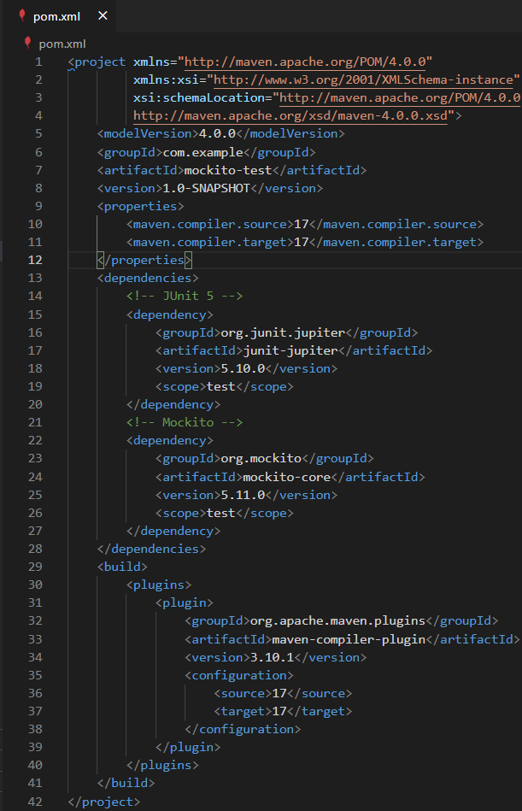

ExternalApi.java (src\main\java\com\example)

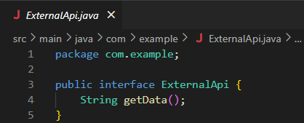

MyService.java (src\main\java\com\example)

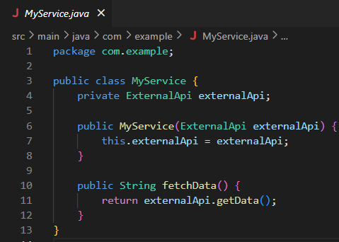

MyServiceTest.java (src\test\java\com\example)

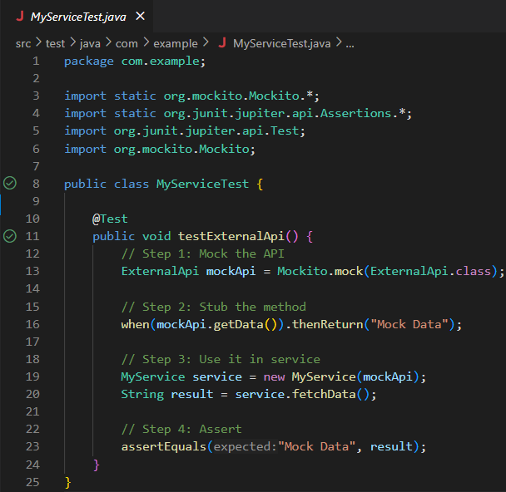

Output: (In new Terminal)

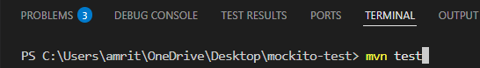

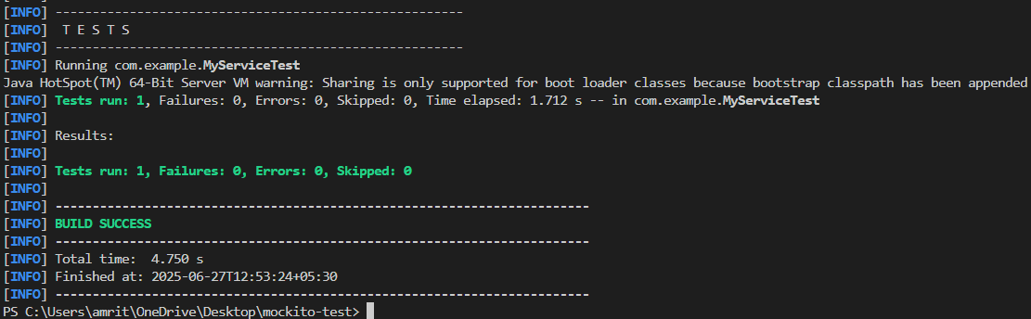

Output: (Run the @Test)

# Exercise 02 – Verifying Interactions

pom.xml

ExternalApi.java (src\main\java\com\example)

MyServiceTest.java (src\test\java\com\example)

Output: (In new Terminal)

Output: (Run the @Test)

